**Q.2) Ans- LabTAT**

**Anderson Darling Normality Test**

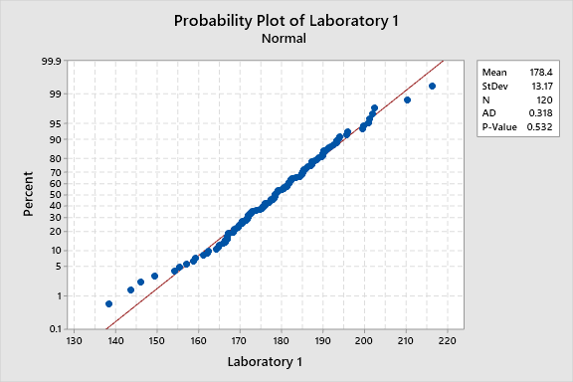

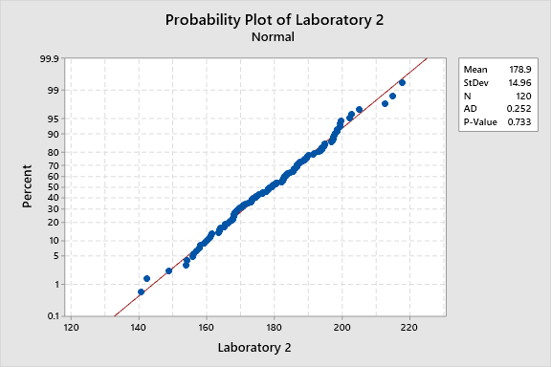

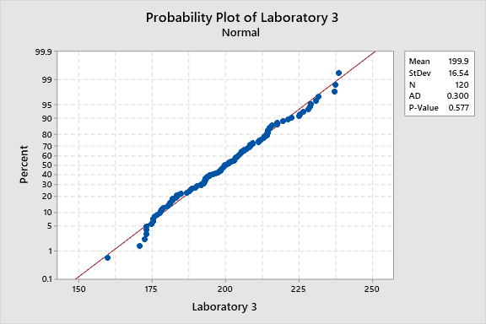

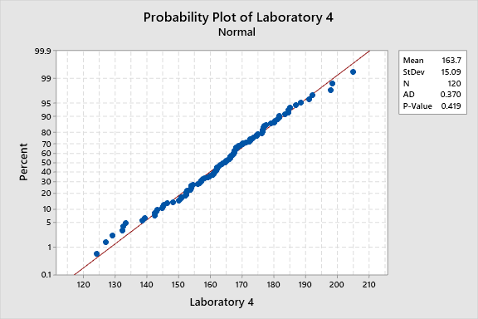

**All four data set are normally distributed as P-value of all is > 0.05**

LABTAT.CSV

**Test and CI for One Variance: Laboratory 1, Laboratory 2, Laboratory 3, Laboratory 4**

**Method**

|  |
| --- |
| σ: standard deviation of Laboratory 1, Laboratory 2, Laboratory 3, ... |
| The Bonett method is valid for any continuous distribution. |
| The chi-square method is valid only for the normal distribution. |

**Descriptive Statistics**

|  |  |  |  |  |  |
| --- | --- | --- | --- | --- | --- |
| **Variable** | **N** | **StDev** | **Variance** | **95% Upper Bound for σ using Bonett** | **95% Upper Bound for σ using Chi-Square** |
| Laboratory 1 | 120 | 13.2 | 174 | 15.0 | 14.8 |
| Laboratory 2 | 120 | 15.0 | 224 | 16.7 | 16.8 |
| Laboratory 3 | 120 | 16.5 | 274 | 18.3 | 18.5 |
| Laboratory 4 | 120 | 15.1 | 228 | 17.1 | 16.9 |

**Test**

|  |  |  |  |
| --- | --- | --- | --- |
| Null hypothesis | | H₀: σ = 1 | |
| Alternative hypothesis | | H₁: σ < 1 | |
| **Variable** | **Method** | | **Test Statistic** | | **DF** | **P-Value** |
| Laboratory 1 | Bonett | | — | | — | 1.000 |
|  | Chi-Square | | 20651.68 | | 119 | 1.000 |
| Laboratory 2 | Bonett | | — | | — | 1.000 |
|  | Chi-Square | | 26622.11 | | 119 | 1.000 |
| Laboratory 3 | Bonett | | — | | — | 1.000 |
|  | Chi-Square | | 32551.21 | | 119 | 1.000 |
| Laboratory 4 | Bonett | | — | | — | 1.000 |
|  | Chi-Square | | 27079.60 | | 119 | 1.000 |

LABTAT.CSV

**Test for Equal Variances: Laboratory 1, Laboratory 2, Laboratory 3, Laboratory 4**

**Method**

|  |  |
| --- | --- |
| Null hypothesis | All variances are equal |
| Alternative hypothesis | At least one variance is different |
| Significance level | α = 0.05 |

*Bartlett’s method is used. This method is accurate for normal data only.*

**95% Bonferroni Confidence Intervals for Standard Deviations**

|  |  |  |  |
| --- | --- | --- | --- |
| **Sample** | **N** | **StDev** | **CI** |
| Laboratory 1 | 120 | 13.1736 | (11.3255, 15.6828) |
| Laboratory 2 | 120 | 14.9571 | (12.8588, 17.8060) |
| Laboratory 3 | 120 | 16.5390 | (14.2188, 19.6893) |
| Laboratory 4 | 120 | 15.0851 | (12.9688, 17.9584) |

*Individual confidence level = 98.75%*

**Tests**

|  |  |  |
| --- | --- | --- |
| **Method** | **Test Statistic** | **P-Value** |
| Bartlett | 6.10 | 0.107 |

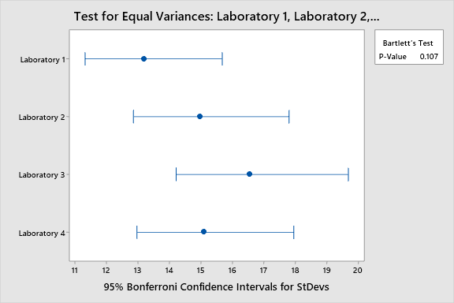

LABTAT.CSV

**One-way ANOVA: Laboratory 1, Laboratory 2, Laboratory 3, Laboratory 4**

**Method**

|  |  |
| --- | --- |
| Null hypothesis | All means are equal |
| Alternative hypothesis | Not all means are equal |
| Significance level | α = 0.05 |

*Equal variances were assumed for the analysis.*

**Factor Information**

|  |  |  |
| --- | --- | --- |
| **Factor** | **Levels** | **Values** |
| Factor | 4 | Laboratory 1, Laboratory 2, Laboratory 3, Laboratory 4 |

**Analysis of Variance**

|  |  |  |  |  |  |
| --- | --- | --- | --- | --- | --- |
| **Source** | **DF** | **Adj SS** | **Adj MS** | **F-Value** | **P-Value** |
| Factor | 3 | 79979 | 26659.7 | 118.70 | 0.000 |
| Error | 476 | 106905 | 224.6 |  |  |
| Total | 479 | 186884 |  |  |  |

**Model Summary**

|  |  |  |  |
| --- | --- | --- | --- |
| **S** | **R-sq** | **R-sq(adj)** | **R-sq(pred)** |
| 14.9863 | 42.80% | 42.44% | 41.83% |

**Means**

|  |  |  |  |  |
| --- | --- | --- | --- | --- |
| **Factor** | **N** | **Mean** | **StDev** | **95% CI** |
| Laboratory 1 | 120 | 178.36 | 13.17 | (175.67, 181.05) |
| Laboratory 2 | 120 | 178.90 | 14.96 | (176.21, 181.59) |
| Laboratory 3 | 120 | 199.91 | 16.54 | (197.23, 202.60) |
| Laboratory 4 | 120 | 163.68 | 15.09 | (160.99, 166.37) |

*Pooled StDev = 14.9863*

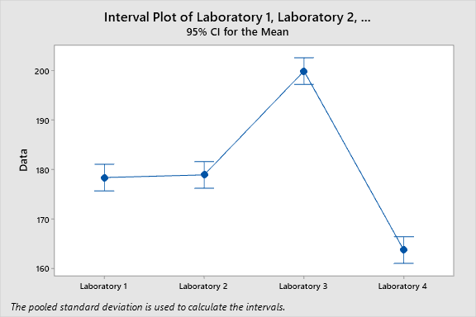

**P-value is 0.00 < 0.05 so rejecting Ho and accepting Ha.**

**All means are not same.**